SUBMITTED BY:

NAME: | M. KARTHIK REDDY
ROLL NO: | CSE25037
YEAR / SEM / SECTION | 2 / 3 / CSE-A
CREDITS | 5

SUBMITTED TO:

NAME: | Dr. RAJKUMAR BATCU
DEPARTMENT | SCHOOL OF COMPUTING
DESIGNATION | ASST. PROFFESOR (SI grade)

S NO: | TITLE | PAGE | REMARKS
1 | WEEK 1:  1a: Recursive countdown from n  1b: Recursive calculation of compound growth factor  1c: Recursive search for emo id in list  1d: Recursive factorial calculation  1e: Recursive fibonacci series

LAB 1

1. AIM:

A rocket launch system displays a countdown. Use no loops. Write a Python program to display the countdown from n to 1, followed by “Launch”.

PROGRAM:

def countdown(n):
print(n)
if n==0:
return 0
else:
return countdown(n-1)

n=int(input("enter number"))
print(countdown(n))

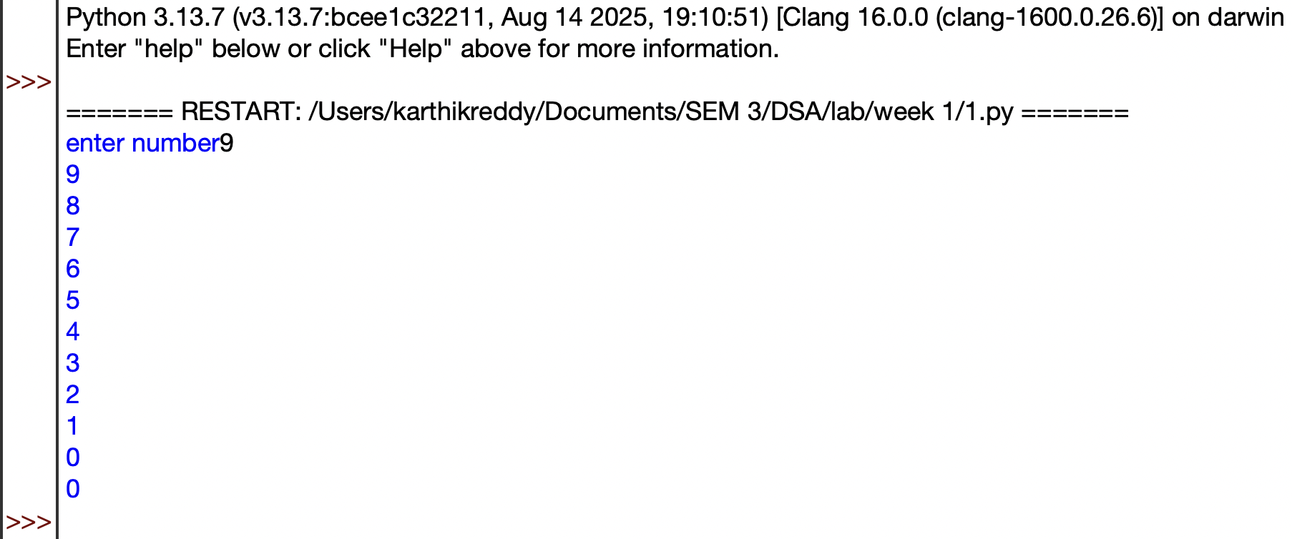
OUTPUT:

EXPLANATION:

- Defines a recursive countdown() function that prints numbers in decreasing order.
- Prints the current value of n before making the recursive call.
- When n becomes 0, the recursion stops.
- Otherwise, the function calls itself with n-1.
- Takes the starting number as input and displays the countdown.

ERROR TABLE:
S.No. | Error Obtained | Rectification
1 | Countdown does not stop | Check the condition when n reaches 0
2 | Program stops for a very large number | Use a loop instead of recursion
3 | Negative numbers are printed unexpectedly | Allow only non negative starting values

2. AIM:

Banks calculate the growth of an investment using compound interest. The formula requires calculating powers, which can be implemented recursively. Write a recursive program to calculate pⁿ (power), where p = principal growth factor and n = number of years.

PROGRAM:

def power(p,n):
if n<=0:
return 1
else:
return p*power(p,n-1)

p=int(input("Enter prinipal"))
n=int(input("Enter number"))
Print(power(p,n))

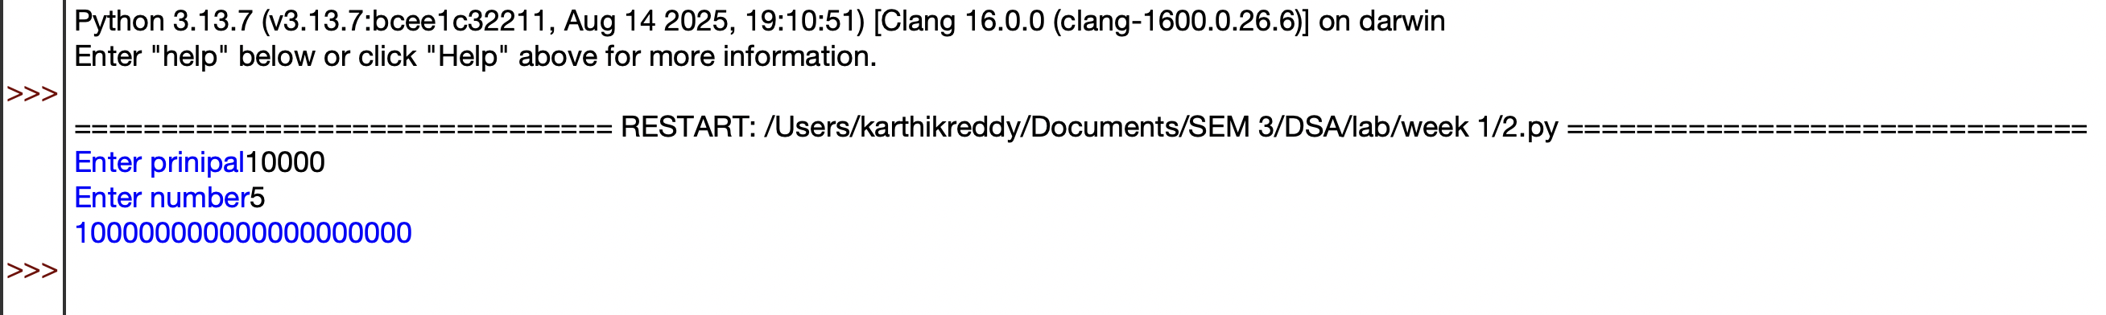
OUTPUT:

EXPLANATION:

- Defines a recursive power() function to calculate \(p^n\).
- Returns 1 when n <= 0, which is the base case.
- Otherwise, multiplies p by power(p, n-1) repeatedly.
- Takes the base (p) and exponent (n) as input.
- Calls the function and prints the calculated power.

ERROR TABLE:
S.No. | Error Obtained | Rectification
1 | Incorrect result for negative exponent | Add separate handling for negative exponents
2 | Program becomes slow for large exponent | Use an efficient power calculation method
3 | Wrong result for exponent zero | Make sure the base case returns 1

3. AIM:

An HR department stores employee IDs in a list. Develop a recursive program to search for a given employee ID. Write a recursive function to search for an employee ID in a list.

PROGRAM:

def search(A,k,n=0):
if n>=len(A):
return -1
if A[n]==k:
return n
return search(A,k,n+1)

A=[1,2,3,4,5,6,7,8]
print(A)
k=int(input("enter id to search"))

Print(search(A,k))

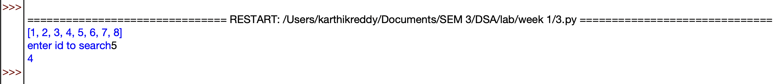
OUTPUT:

EXPLANATION:

- Defines a recursive search() function to find the target element in the list.
- Checks each element starting from index 0 using recursion.
- If the target is found, its index is returned.
- If the end of the list is reached, -1 is returned.
- Takes the target value as input and displays the search result.

ERROR TABLE:
S.No. | Error Obtained | Rectification
1 | Target element is not found | Check whether the target exists in the list
2 | Recursion stops before checking all elements | Verify the index increment in the recursive call
3 | Program stops for a large list | Use an iterative search method

4. AIM:

In a logistics company, the number of possible ways to arrange n different parcels is calculated using the factorial formula (n!). Develop a recursive program to calculate the factorial of a given number.

PROGRAM:

def factorial(n):
if n<=0:
return 1
else:
return n*factorial(n-1)

n=int(input("Enter number"))
print(factorial(n))

OUTPUT:

EXPLANATION:

- Defines a recursive factorial() function to calculate the factorial of a number.
- Returns 1 when n <= 0, which also handles 0!.
- Otherwise, multiplies n by factorial(n-1) until reaching the base case.
- Takes a number as input from the user.
- Calls the function and prints the factorial result.

ERROR TABLE:
S.No. | Error Obtained | Rectification
1 | Incorrect factorial for negative input | Restrict the input to non negative numbers
2 | Program stops for a large number | Use an iterative approach
3 | Wrong factorial result | Check the recursive multiplication and base condition

5. AIM:

Write a recursive Python program to print the first n terms of the Fibonacci series.

PROGRAM:

def fibonacci(n):
if n<=0:
return 0
elif n==1:
return 1
else:
return fibonacci(n-1)+fibonacci(n-2)

n= int(input("Enter terms"))
for i in range(n):
print(fibonacci(i))

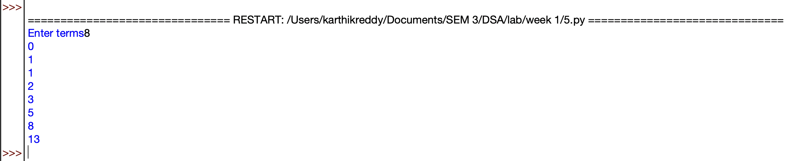
OUTPUT:

EXPLANATION:

- Defines a recursive fibonacci() function to calculate Fibonacci numbers.
- Returns 0 for n <= 0 and 1 for n == 1.
- For other values, it recursively adds the previous two Fibonacci numbers.
- Takes the number of terms from the user.
- Uses a loop to generate and print each Fibonacci term.
- The sequence starts as 0, 1, 1, 2, 3, 5, ....

ERROR TABLE:
S.No. | Error Obtained | Rectification
1 | Program runs very slowly | Use an iterative or optimized approach
2 | Incorrect sequence is displayed | Check the base conditions for 0 and 1
3 | Program stops for large input | Avoid excessive recursive calls

LAB 2

1. AIM:

Write a program to perform linear search on a given input.

PROGRAM:

def linearSearch(a,key):
for i in range(n):
if a[i]==key:
return i
return -1

n=int(input("Enter number of elements"))
a=[]
for i in range(n):
x=int(input("enter elements"))
a.append(x)
key=int(input("Enter target element"))
Print(linearSearch(a,key))

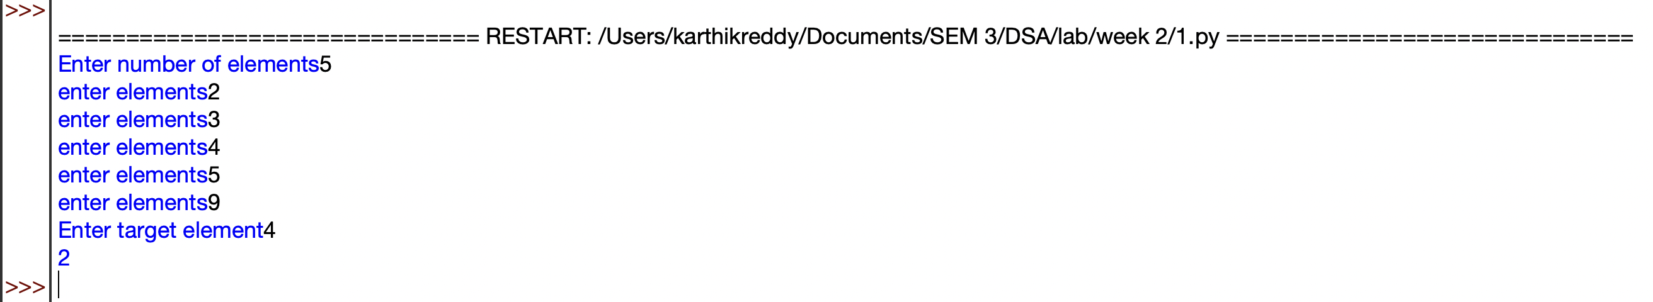
OUTPUT:

EXPLANATION:

- Takes the number of elements and stores them in a list.
- Takes the target element to be searched.
- linearSearch() checks each element one by one.
- If the target is found, its index is returned.
- If not found, -1 is returned.
- The result is displayed using print().

ERROR TABLE:
S.No. | Error Obtained | Rectification
1 | Element is not found | Check whether the required element is present in the list
2 | Wrong index is displayed | Check the list indexing starting from 0
3 | Search stops unexpectedly | Verify the range used in the for loop

2. AIM:

Write a Python program to perform binary search on the given input. Verify by taking sorted array & unsorted array as input.

PROGRAM:

def binary_search(a, low, high, key):
while low <= high:
mid = (low + high) // 2

if a[mid] == key:
return mid
elif a[mid] > key:
high = mid - 1
else:
low = mid + 1

return -1

n = int(input("Enter number of elements: "))
if n <= 0:
print("Number of elements must be positive.")
a = []
for i in range(n):
x = int(input("Enter element: "))
a.append(x)
a.sort()
print("Sorted list:",a)
key = int(input("Enter target element: "))
result = binary_search(a, 0, len(a) - 1, key)
if result != -1:
print("Element found at index",result)
else:
print("Element not found.")

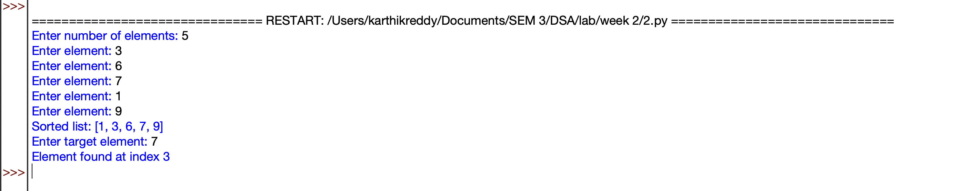
OUTPUT:

EXPLANATION:

- Takes the number of elements and stores them in a list.
- Sorts the list using a.sort() because binary search requires sorted data.
- Calculates the middle element and compares it with the target.
- If the target is smaller or larger, searches only the appropriate half.
- Returns the index if found; otherwise returns -1.
- Displays whether the element is found or not.

ERROR TABLE:
S.No. | Error Obtained | Rectification
1 | Wrong element is returned | Make sure the list is sorted before searching
2 | Search gives incorrect index | Check the calculation of the middle index
3 | Element is not found | Verify the low and high boundaries

LAB 3

1. AIM:

Write a program to sort the elements using a bubble sort technique. Take an input elements from user

PROGRAM:
def bubble_sort(arr):
n=len(arr)
for i in range(n-1):
for j in range(n-i-1):
if arr[j]>arr[j+1]:
arr[j],arr[j+1]=arr[j+1],arr[j]
return arr
num=int(input("Enter number of elements: "))
arr=[]
for i in range(num):
x=int(input("Enter element: "))
arr.append(x)
print(arr)
print("Sorted array is: ",bubble_sort(arr))

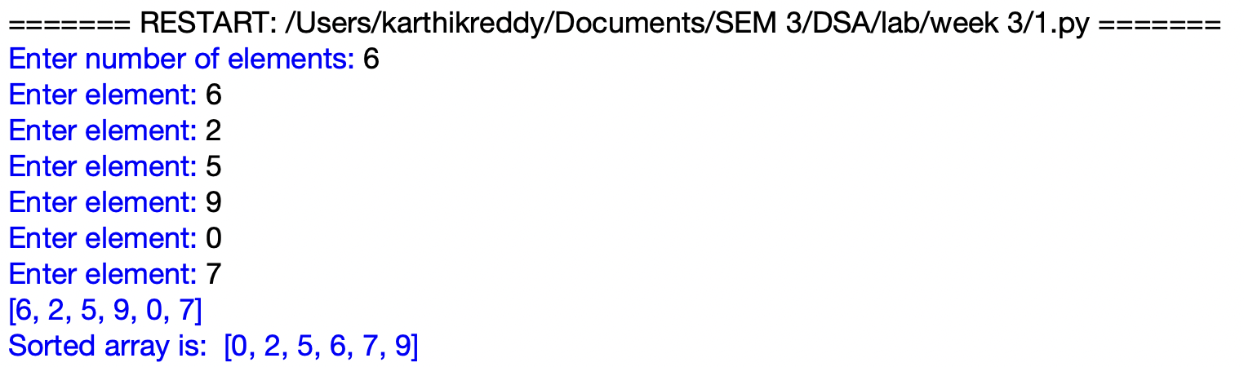
OUTPUT:

EXPLANATION:
- Defines the bubble_sort function and finds the number of elements in the list.
- Compares adjacent elements using two nested loops.
- Swaps the elements if they are in the wrong order.
- Repeats the process until all elements are arranged in ascending order.
- Takes the elements as input from the user and stores them in a list.
- Calls bubble_sort and displays the sorted array.

ERROR TABLE:
S.No. | Error Obtained | Rectification
1 | IndexError while comparing elements | Check the loop range and array size
2 | Elements are not sorted correctly | Check the swapping condition
3 | Incorrect number of elements processed | Make sure the entered count matches the elements

2. AIM:

Write a program to sort the elements using a insertion sort technique. Take an input elements from user

PROGRAM:
def insertion_sort(arr):
n=len(arr)
for i in range(1,n):
key=arr[i]
j=i-1
while j>=0 and arr[j]>key:
arr[j+1]=arr[j]
j=j-1
arr[j+1]=key
return arr
num=int(input("Enter number of elements: "))
arr=[]
for i in range(num):
x=int(input("Enter element: "))
arr.append(x)
print(arr)
print("Sorted array is: ", insertion_sort(arr))

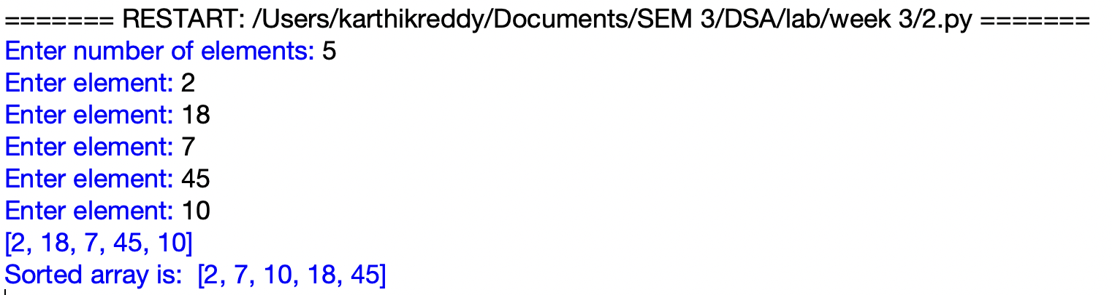
OUTPUT:

EXPLANATION:
- Defines the insertion_sort function and starts from the second element of the list.
- Stores the current element in key and compares it with the previous elements.
- Moves larger elements one position to the right.
- Places key in its correct position in the sorted portion of the list.
- Repeats the process until all elements are sorted.
- Displays the original and sorted arrays.

ERROR TABLE:
S.No. | Error Obtained | Rectification
1 | Elements are not sorted correctly | Check the position where key is inserted
2 | IndexError while shifting elements | Check the condition j >= 0
3 | Some elements are overwritten | Place key after completing the shifting process

3. AIM:

Write a program to sort the elements using a selection sort technique. Take an input elements from user

PROGRAM:
def selection_sort(arr):
n=len(arr)
for i in range(n-1):
min_index=i
for j in range(i+1,n):
if arr[j]<arr[min_index]:
min_index=j
arr[i] , arr[min_index] = arr[min_index] , arr[i]
return arr
num=int(input("Enter number of elements: "))
arr=[]
for i in range(num):
x=int(input("Enter element: "))
arr.append(x)
print("Sorted array is: ", selection_sort(arr))

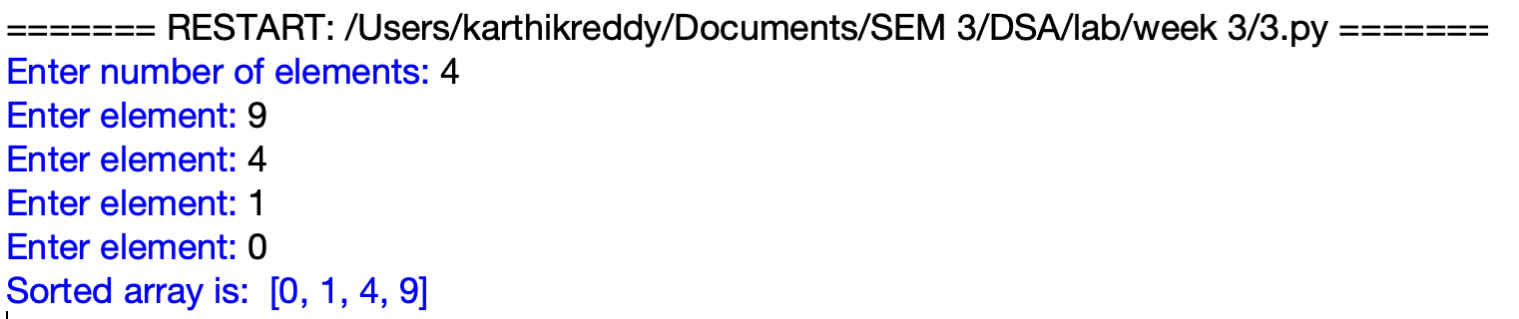
OUTPUT:

EXPLANATION:
- Defines the selection_sort function and assumes the first unsorted element as the minimum.
- Compares it with the remaining elements to find the smallest element.
- Stores the position of the smallest element in min_index.
- Swaps the smallest element with the element at the current position.
- Repeats the process until the entire list is sorted.
- Takes input elements and displays the sorted array.

ERROR TABLE:
S.No. | Error Obtained | Rectification
1 | Incorrect sorting of elements | Perform the swap after finding the minimum element
2 | Elements are swapped multiple times | Move the swap statement outside the inner loop
3 | Minimum element is selected incorrectly | Check the min_index update condition

4. AIM:

Write a program to sort the elements using a merge sort technique. Take an input elements from user

PROGRAM:
def merge_sort(a):
if len(a)>1:
mid=len(a)//2
left=a[:mid]
right=a[mid:]
merge_sort(left)
merge_sort(right)
i=j=k=0
while i<len(left) and j<len(right):
if left[i]<right[j]:
a[k]=left[i]
i+=1
else:
a[k]=right[j]
j+=1
k+=1
while i<len(left):
a[k]=left[i]
i+=1
k+=1
while j<len(right):
a[k]=right[j]
j+=1
k+=1
num=int(input("Enter number of elements: "))
a=[]
for i in range(num):
x=int(input("Enter element: "))
a.append(x)
print("Original array:",a)
merge_sort(a)
print("Sorted array:",a)

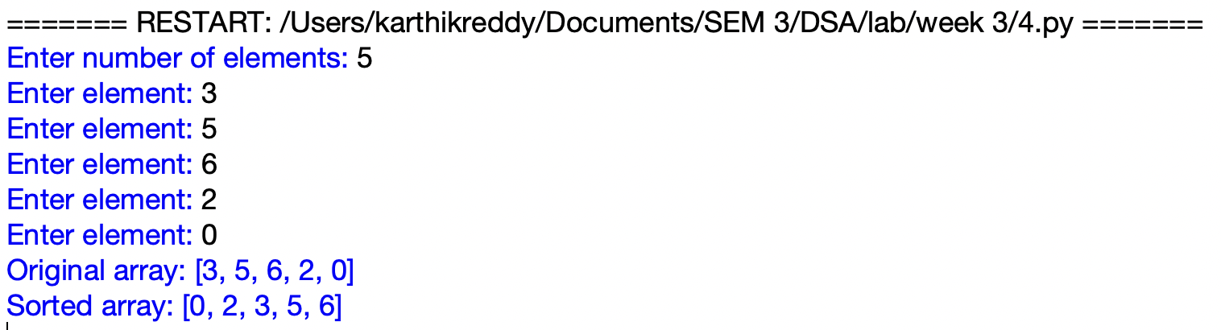
OUTPUT:

EXPLANATION:
- Defines the merge_sort function and divides the array into two halves.
- Recursively divides each half until single elements remain.
- Compares elements from the left and right halves.
- Merges the elements back into the array in ascending order.
- Continues merging until the complete array is sorted.
- Takes input elements and displays the original and sorted arrays.

ERROR TABLE:
S.No. | Error Obtained | Rectification
1 | Elements are not merged correctly | Check the comparison between left and right arrays
2 | Some elements are missing after merging | Check the remaining element loops
3 | Incorrect sorted output | Verify the values of i, j and k during merging

5. AIM:

Write a program to sort the elements using a quick sort technique. Take an input elements from user

PROGRAM:
def quicksort(a,low,high):
if low<high:
i=low
j=high
pivot=low
while i<j:
while i<=high and a[i]<=a[pivot]:
i+=1
while a[j]>a[pivot]:
j-=1
if i<j:
a[i],a[j]=a[j],a[i]
a[pivot],a[j]=a[j],a[pivot]
quicksort(a,low,j-1)
quicksort(a,j+1,high)

num=int(input("Enter number of elements: "))
a=[]
for i in range(num):
x=int(input("Enter element: "))
a.append(x)
print(a)
n=len(a)
quicksort(a,0,n-1)
print("Sorted array is:",a)

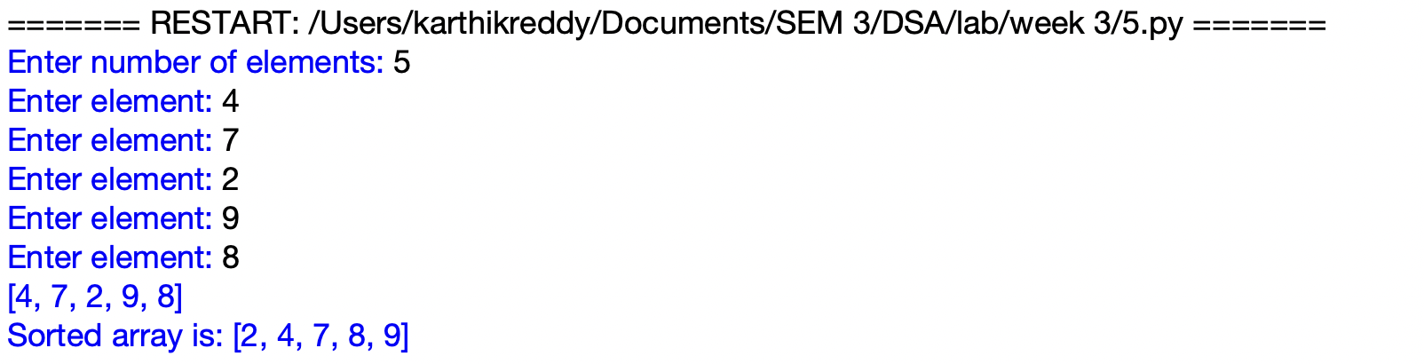
OUTPUT:

EXPLANATION:
- Defines a recursive Quick Sort function and selects the first element as the pivot.
- Uses two pointers, i and j, to compare and arrange elements around the pivot.
- Swaps elements when they are on the wrong side of the pivot.
- Places the pivot in its correct position after partitioning.
- Recursively sorts the elements before and after the pivot.
- Takes the elements as input and performs the sorting operation.

S.No. | Error Obtained | Rectification
1 | UnboundLocalError for i or j | Keep the partitioning code inside the if block
2 | RecursionError for large input | Check the recursive calls and pivot position
3 | Sorted array is displayed as None | Print the list after calling quicksort

ERROR TABLE:

